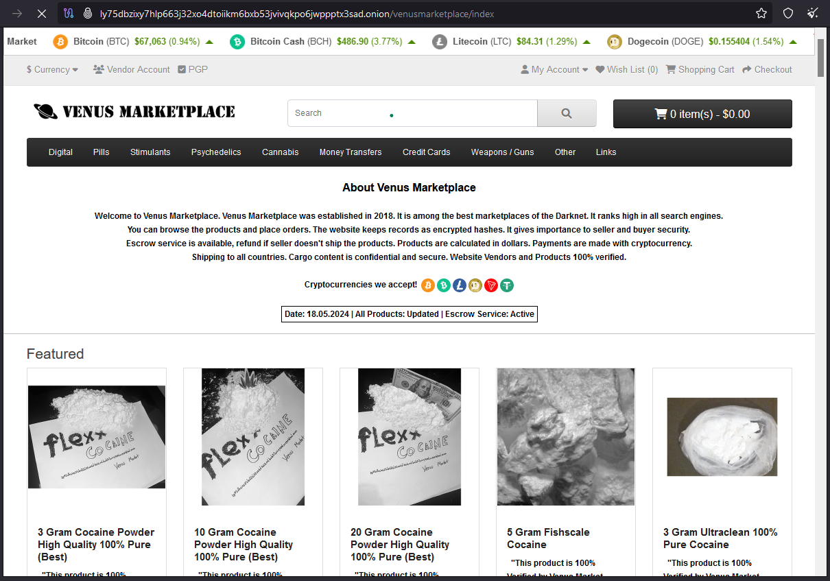

working = http://ly75dbzixy7hlp663j32xo4dtoiikm6bxb53jvivqkpo6jwppptx3sad.onion/